CANADA 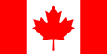 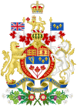
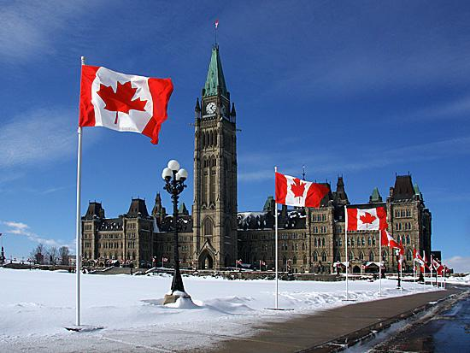
Canada is a country in North America and the second largest country in the world in area, after Russian Federation. It extends from the Atlantic to the Pacific Ocean and northward into the Arctic Ocean. It has common border with the USA and forms the world's largest land border.
Total area of Canada is 9984670 km². 75% of its territory is north zone. The population is 35 000 000 people.
The capital of Canada is Ottawa. The country is officially bilingual and multicultural, English and French Languages are official at the federal level.
Native people of Canada are Indians, Escimos and Mestizo. Canada is very various from the ethnic point of view.
Common culture of Canada was formed under the influence of indigenous, English and French traditions.

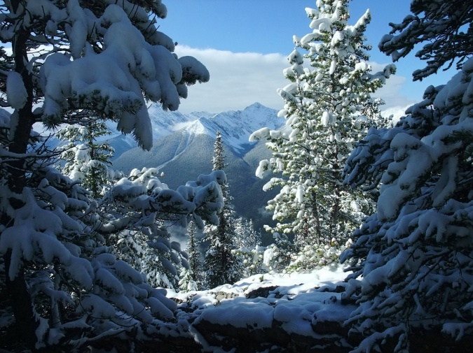
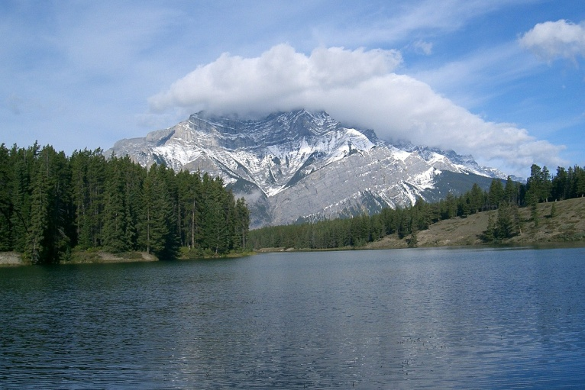
Today, there are no national dishes in Canada, because of multinational structure of the country. Canadians like meat and fish dishes very much. Juicy steaks, beefsteaks, roast beefs, splints which you can see everywhere is common Canadian food nowadays. Soups, puree soups, bouillons take not the last place in Canadian cuisine. Another proud of Canadian national cuisine is maple syrup. Production method of maple juice was borrowed from Indians. Also, Canada is the main producer and consumer of cheese.
Canadian national songs are songs of Indian tribes, first immigrants from France and Great Britain. In this song, they saved their traditions and culture.
Hockey is the main national sport in Canada. It appeared in its modern way exactly in Canada.
Canadian symbols are maple syrup, Canada Goose, loon, and Canadian beaver.
Canadian celebrate their national holiday - the day of indigenous people on June 21. Exactly in this day indigenous people celebrated the days of its culture and legacy, it is also the day of summer solstice - the longest day in a year.

