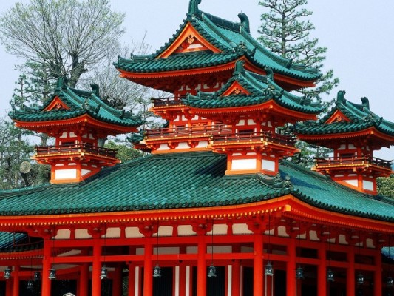
JAPAN 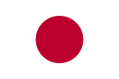 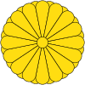
Japan is an island state in East Asia, located in the Pacific Ocean. Japan is a stratovolcanic archipelago of 6.852 islands. The four largest islands are Honshu,Hokkaido, Kyushu, and Shikoku, which together comprise about ninety-seven percent of Japan's land area. Japan has the world's tenth-largest population, with over 127 million people. The capital of Japan is Tokyo.
Official language is Japanese. Almost all population of the state (according to date 127 million people) speaks Japanese. About 98% of the population is actually Japanese. The largest groups of indigenous minorities are Ryukyuan people (about one and a half million people), the Ainu, as well as social minority - Burakumin.
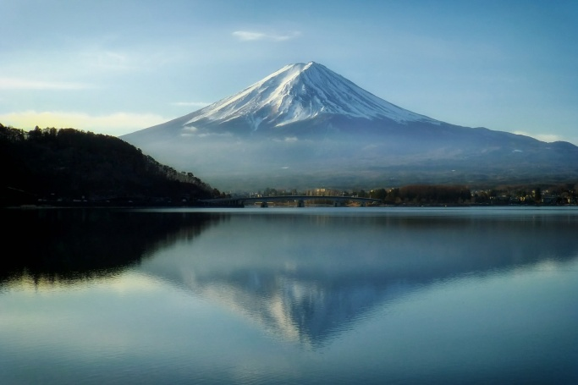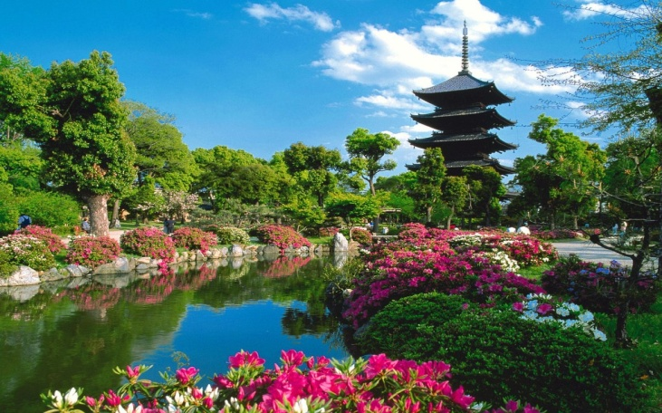

The basis of Japanese cuisine is rice ("gohan"). The second most important staple food is Japanese fish. To preserve food in conditions of high humidity it is often salted, fermented or pickled, examples of these dishes can be natto, umeboshi, tsukemono and soy sauce. One of the most popular Japanese foods abroad is sushi. The Japanese have a lot of different soups, but the most traditional - Miso soup. This soup includes miso paste. A special place in traditional Japanese cuisine takes the Japanese tea ceremony. Japanese classical music genre is gagaku, it is the music played by the orchestra (bells, drums and wind instruments): «J-pop», «J-rock», «Visual kei». The difference is that the traditional Japanese music based on human breath intervals rather than on a mathematical reference.

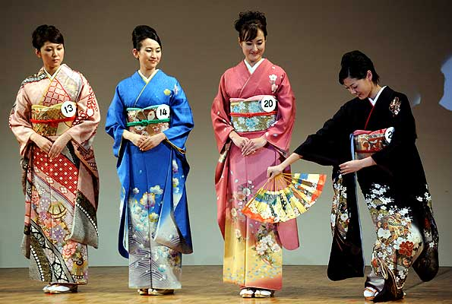

Demonstration of traditional Japanese dance consists of a pre-eminent decision poses. The majorities of dances do not imply any sudden movements, and can be performed at one and a half square meters of floor. Almost all the dance, torso is strictly vertical, kata differ in the position of the head, shoulders, arms. Folding fan is the main dance accessory. The most famous Japanese dances are: "Gion Coutu", "Bon Odori".
Decorative art in Japan include: ningyo (traditional Japanese doll), netsuke (stick), origami, ikebana, bonsai, Temari (embroidery on the balls).
Cherry blossom is considered the main event of the Japanese. The Japanese calendar has no national holiday, or special holidays or weekends associated with this magnificent natural wonder. But psychologically it is undoubtedly a holiday for the Japanese themselves, and for many foreign tourists.
