FINLAND 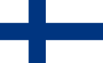 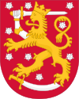

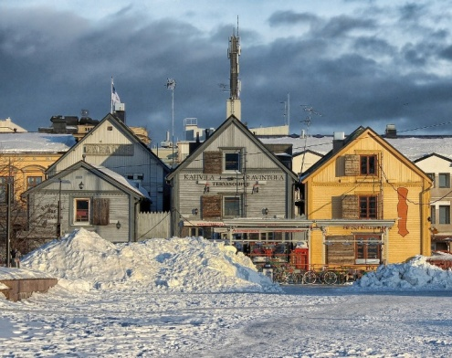
Finland officially the Republic of Finland, is a Nordic country in Northern Europe. Finland is located in Northern Europe a large part of its territory is above the Arctic Circle (25%). Finland bordered by Sweden to the west, Norway to the north and Russia to the east; Estonia lies to the south across the Gulf of Finland. The total area of ​​the country, including the islands, located in Bothnia and Gulf of Finland, 338 145 km2 (the area of ​​land -305 470 km2).
The capital of Finland is Helsinki. Finland's population is more than 5 million people. The largest ethnic minorities in Finland are: Karelian, Swedish-speaking Finns (about 291,000) , Romani people, Sami and Finnish Tatars.
Until 1809 Swedish was the only official language of the Grand Duchy of Finland. After that Finland became independent and now Finnish and Swedish are the official languages of the country.
In 1992, the "Law of the Sami language" started to work. According to the law the Sami language has a special status in the country: in particular, the decisions of the Parliament, decrees and government regulations that relate to Sami issues must be translated also in the Sami language.
Leisure and entertainment activities in Finland include fishing, hunting and Finnish sauna. Puppet production is widely spread in Finland. Association of women in the so-called "Martha" began to make dolls to support the employment of women.
Finnish folk dance culture is international. Dance of Lapland people with smooth moves, power running, clap his hands is a special layer of the northern choreography.
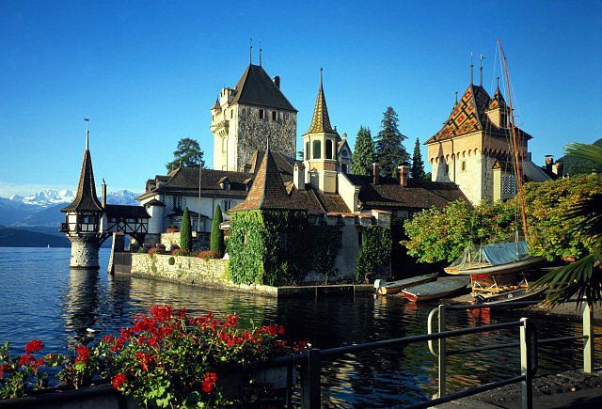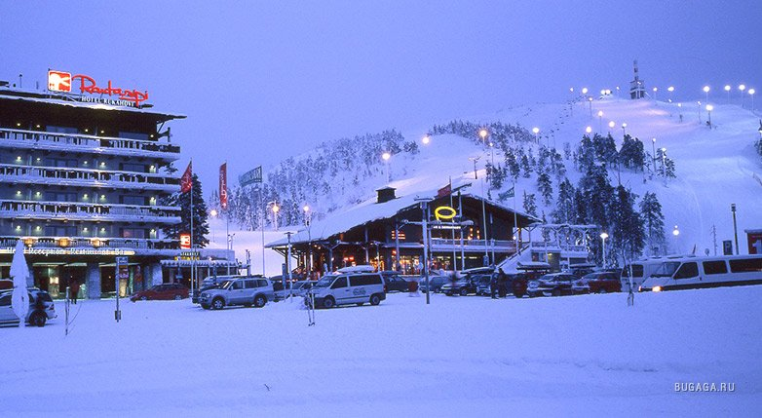

Special influence on Finnish music had a traditional Karelian melodies and lyrics that took their inspiration from the epic "Kalevala". Karelian culture is based on Finnish myths and legends. The most popular Finnish dishes are fish. The most common are: Graavi lohi (rainbow trout in its own juice), Rosolli (herring salad), Rapu (crayfish). The most used methods of cooking in Finland are boiling and steaming. If you find yourself in Finland on Easter, you certainly will treat the traditional Easter dishes – kalakukko. This is a cake that looks like a regular rye bread, but inside, instead of the flesh there is filling of fish and lard. Besides fish pie, for Easter in Finland people usually serve up on the table sweet pudding - Mämmi.
The national holidays include the Day of the Sami people, which is celebrated on February 6, the Day of the national epic "Kalevala" which is celebrated on February 28 and Day of the Swedish culture on November 6th. Mikael Agricola's Day, the day of the Finnish language is celebrated on April 9.

